125 South Water Street

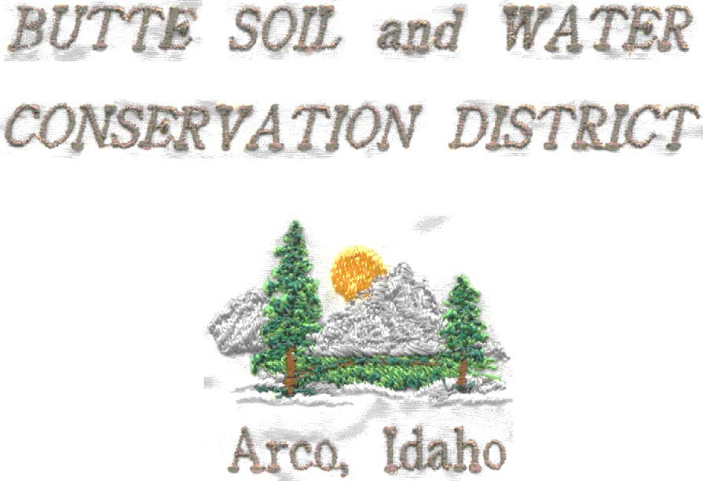
FIVE-YEAR RESOURCE CONSERVATION BUSINESS PLAN

JULY 1, 2016- JUNE 30, 2021

FORWARD

The Butte Soil and Water Conservation District is one of 50 Conservation Districts in Idaho. Idaho Soil and Water Conservation Districts are political subdivisions of the state government but are not state agencies. Conservation Districts are charged with carrying out a program for the conservation, use and development of soil, water, and other natural resources.

Conservation Districts are the primary entities to provide assistance to private landowners and land users in the conservation, sustainment, improvement and enhancement of Idaho’s natural resources. They are catalysts for coordinating and implementing conservation programs, channeling expertise from all levels of government into action at the local level. Programs are nonregulatory; science-based technical assistance, incentive-based financial programs and informational and educational programs at the local level.

Both by legislation and by agreement the USDA Natural Resources Conservation Service provides technical assistance to landowners and land users through Conservation
Districts. Each Conservation District in Idaho has a signed Mutual Agreement with the Secretary of Agriculture and the Governor of Idaho that establishes a frame work for cooperation.

The Goal of The Butte Soil and Water Conservation District is to set high standards for conservation and wise use of the natural resources in the district. The District is concerned with the total development, use and conservation of our soil, water and wildlife resources.

This Annual Plan/Five-Year Resources Conservation Business Plan was developed not only to guide the Conservation District, but also to encourage cooperation among landowners, government agencies, private organizations, and elected officials. Through knowledge and cooperation, all concerned can ensure a sustainable natural resource base for present and future generations in the Butte Soil and Water Conservation District.

This document identifies the resource needs in the Conservation District and presents a resource conservation action plan for meeting these needs.

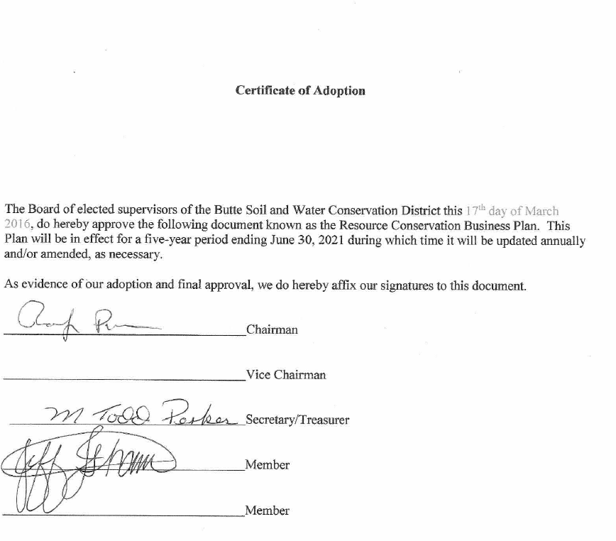

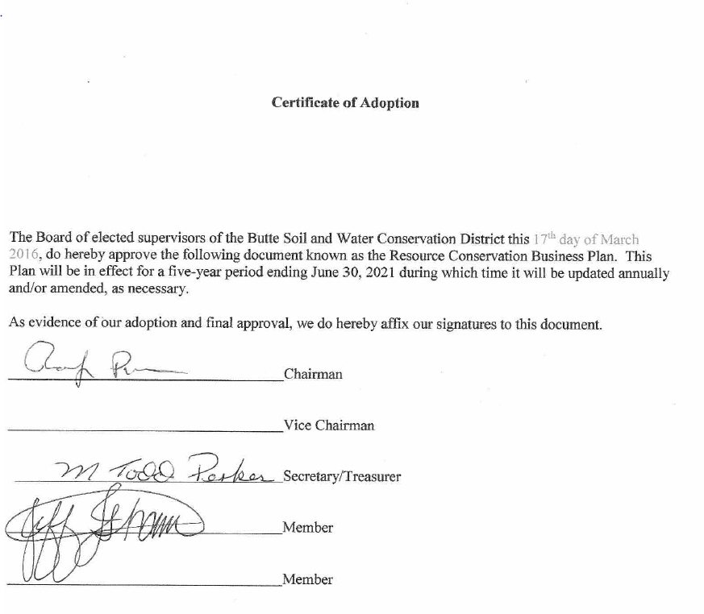

Forward

Table of Contents
Butte Soil and Water Conservation District Annual Plan/Resource Conservation Business Plan

Page

Section 1: Physical Characteristics of the District

- Location of the District in Relation to the State 5
- District Boundary 6
- Land use Cover 7
- Land Status 8
- Geology and Physical Geography 9
- Climate 10
Section 2: Economic Conditions and Outlook
- Population 11
- Type of employment 11
- Demographics 12
- Status of Ag economy and Outlook 12
- Agricultural statistics 12
Section 3: Assessment
- Soil resources 13
- Water resources (quantity) 14
- Water resources (quality) 14
- Air quality 15
- Forest lands, grass lands, pasture, hay land and rangeland
- Livestock production
- Fish and wildlife 15
- District Operations 16
- Financial 16
- Administrative 16
- Technical Assistance 16
Section 4: Identify and Prioritize Objectives 16
Section 5: Water Quality Component 16
Section 6: Identify and Prioritize Projects 20
Section 7: Implementation - FY 2016/2020 Annual Plan of Work Soils 30
APPENDIX A. History, Administration and Operation, Policies, Partners 34

Section 1: Physical Characteristics of Butte SWCD
IDAPA 60.05.02.025.01)

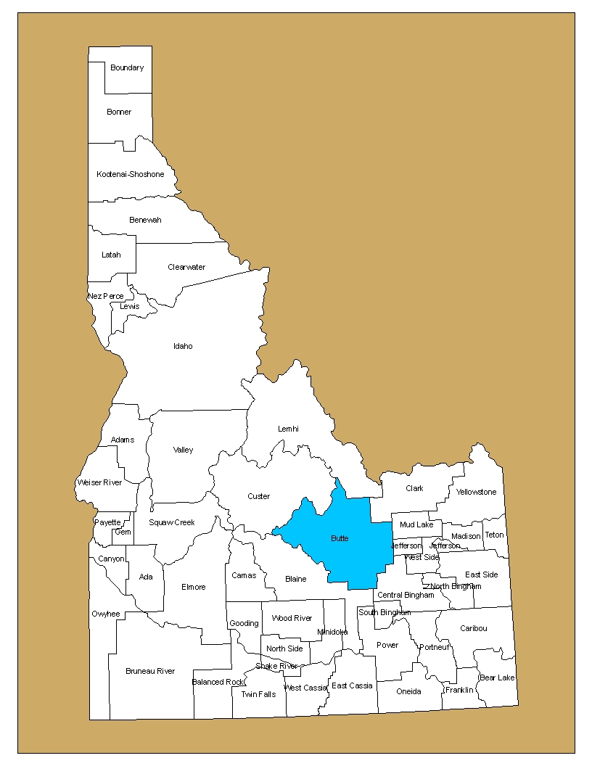

Butte SWCD consists of all of Butte County and the portion of Custer County within the Big Lost River Watershed.

- District Boundaries and Cities

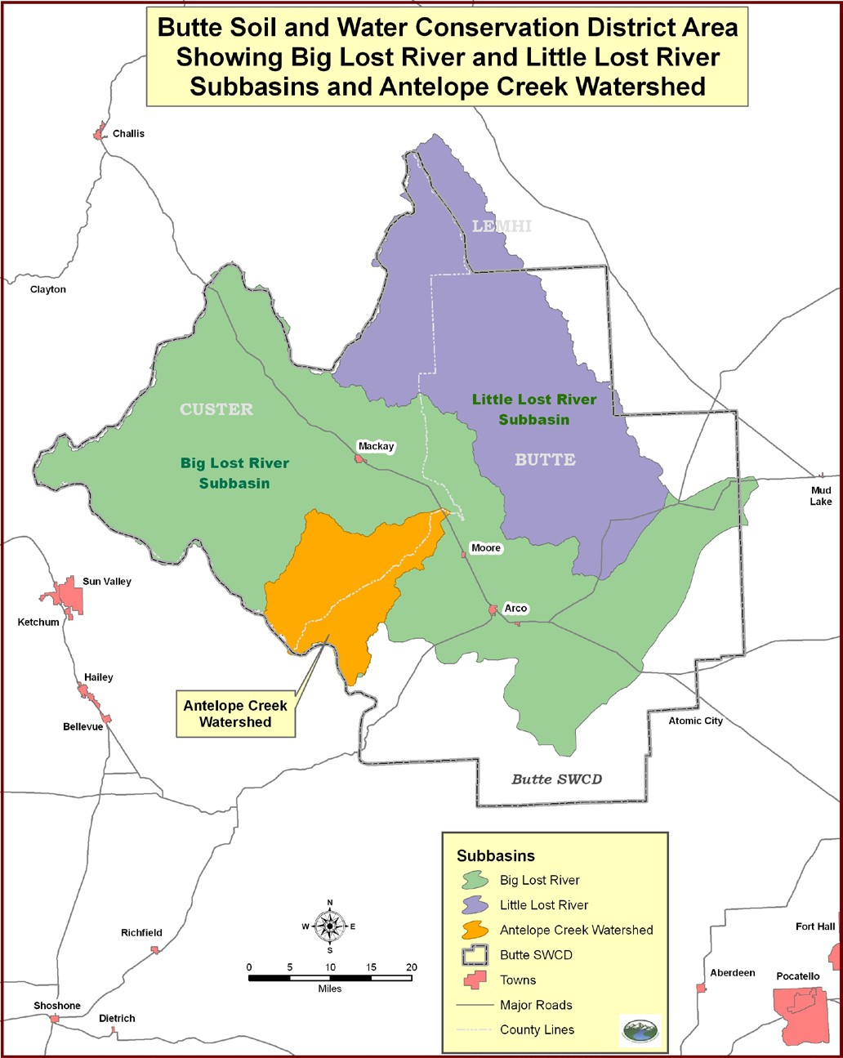

- Land Use Cover

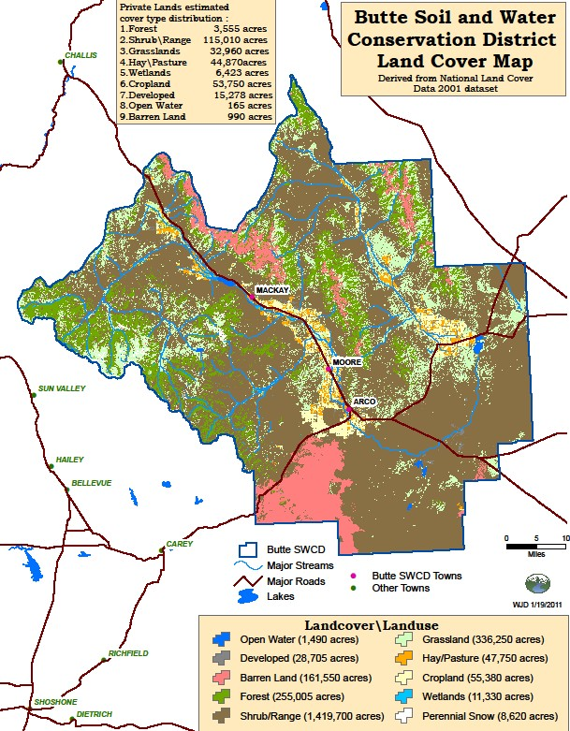

- Land Status

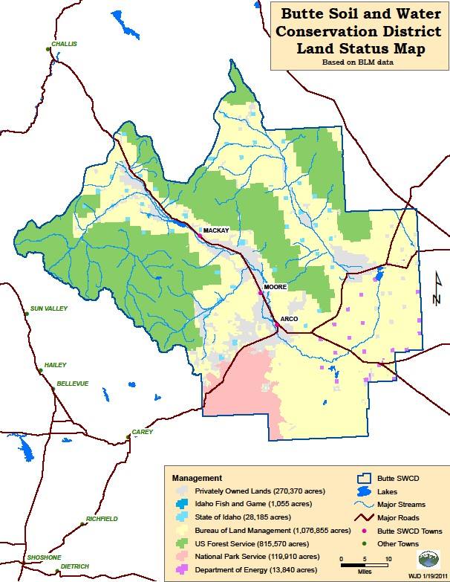
- Geology and Physical Geography

The Craters of the Moon National Monument is twenty miles southwest of Arco. It contains basalt flows that are only a few thousand years old. The mountains north of the monument, west of Newman Canyon and into Copper Basin are old Challis volcanic rocks; predominantly rhylite resting on carboniferous deformed sedimentary rocks.

The first small range of mountains to the west of the Big Lost River between Arco and Willow Creek Summit are predominately Paleozoic limestones and dolomites.

The mountain range to the east of Arco to Ramshorn Canyon consists of younger limestone rocks, Carboniferous in age. From Ramshorn Canyon to Elbow Canyon Mountains of older dolomite and limestone rock occur. At Pass Creek a fault occurs that exposes deep Paleozoic dolomite on the south and deep Challis volcanic on the north.

Moving north from Pass Creek to Borah Peak the geology becomes very mixed. Quartzite, argillite, sandstone, basalt, limestone and dolomite rocks are exposed.

Relatively broad outwash fans, fan terraces and alluvial fans occur at the foot of the mountains on both sides of the Big and Little Lost River Valleys. These fans are formed of deep alluvium deposited in Pleistocene after glaciation produced by periods of high annual precipitation. Few streams from the mountains maintain channels across the fans because of the fan terraces are made of coarse textured material.

In the Thousand Springs area limestone bedrock is very close to the surface; this is suggested by the numerous small hills of Whiteknob Limestone that protrude through the valley fill. This condition causes a perched water table and makes most of the area marshland.

Copper is mined in the Mackay mining district, which runs southwest of Mackay into Copper Basin. Copper and other deposits have been known in the area since 1900 and the aggregate production from about 50 properties neared $10 million. The mining area is a complex of granites, quartz, Challis volcanic and Paleozoic limestone. The intrusive rocks are the source of copper ore near Mackay. Large mines are worked when copper prices are high. There is interest in gold and silver mining in the Champagne Creek area. A mine operated there in the 1990’s but is closed at this time, monitoring and rehabilitation are ongoing.

The topography of the district is varied, with elevations ranging from 4,820 feet at Howe to 12,655 feet at Mount Borah. The Lost River Mountain Range occurs in the Midwest point of a great deformation, which extends from the southern tip of Chile to Alaska.

On October 28, 1983, an earthquake measuring 7.3 on the Richter scale, produced a fault scarp, with an average vertical displacement of 8 to 10 feet, which extends from the epicenter at Mount Borah to McGowan Creek, a distance of more than 20 miles. The Thousand Springs Valley became a catchment basin for the additional surface water. However, most of this “new water”, which was several times the normal flow, entered the Big Lost River and the Mackay Reservoir.

- Climate
Climatic conditions are varied because of rapid elevation changes and air currents controlled by numerous high mountains. Elevations of irrigated farmland in the district range from 4,820 feet at Howe to 6,260 feet elevation in Chilly. This elevations change creates an 8-day growing season difference in the district. Air currents near Mackay produce a longer growing season that at Arco even though Mackay is 577 feet higher in elevation. Rainfall varies from 8 to 10 inches in the valleys to 20 inches on the higher mountains.

The following chart shows elevation, precipitation, frost-free days at weather stations located in the district:

TEMPERATURES, PRECEIPATION AND FROST FREE DAYS

Station | Elevation | Average Annual Temp. | Average Annual Precip. | Average Annual Frost-free Days Above  32 F.
Arco | 5320 | 41.8 | 9.92 | 88
Mackay | 5897 | 41.7 | 9.73 | 97
Grouse | 6100 | 37.0 | 12.38 | 28
Howe | 4820 | 42.8 | 8.85 | 76
May |  |  | 7.94
Craters of the Moon | 5897 | 40.8 | 16.50 | 78
Chilly/Barton Flats | 6260 | 38.7 | 8.17 | 85
INEL Central | 4790 | 42.3 | 8.24 | 91

Snow Water Equivalents
SNOW COURSE DATA -- 20-YEAR AVERAGE:

Snow Course Elevation Jan Feb March April May June

BIG LOST RIVER DRAINAGE

Bear Canyon | 7900 | 8.3 | 12.4 | 15.4 | 19.3 | 17.9 | 0.0
Copper Basin | 7640 | 3.3 | 6.3 | 8.1 | 10.5 | 7.5 | 0.0
Dry Fork | 7220 |  |  | 14.4 | 16.3
Fishpole Lake | 9300 |  |  | 17.0 | 22.1 | 23.6
Iron Bog | 7650 |  |  | 12.4 | 13.5
Lost Wood Divide | 7900 | 10.1 | 16.0 | 19.8 | 24.0 | 22.4 | 5.6
Smiley Mountain
Stickney Mill | 7430 | 4.1 | 6.0 | 8.2 | 10.4 | 6.0 | 0.0

LITTLE LOST RIVER DRAINAGE

Hilts Creek | 8000 | 5.4 | 7.7 | 9.4 | 11.6 | 9.3 | 0.0
Moonshine | 7440 | 4.8 | 7.3 | 9.0 | 10.7 | 8.3 | 0.0
Sawmill Canyon | 7000 | 3.8 | 5.7 | 7.0 | 7.9 | 4.3 | 0.0
Wet Creek | 7680 | 4.9 | 7.8 | 10.0 | 12.8 | 7.4 | 0.0

Section 2: Economic Conditions and Outlook
(IDAPA.60.05.02.025.02)

- Population

The combined population of the district is approximately 4,500 with Butte County at 2,890 and the portion of Custer County in the district at 1,400. Approximately 50 percent of the population of the district is located in the towns of Arco, Moore, Butte City and Mackay. Of the total population 2% are minority, primarily Mexican-American.

- Types of Employment

Butte County

Occupations

- Agriculture, forestry, fishing and hunting (26%)
- Construction (13%)
- Public administration (9%)
- Professional, scientific, and technical services (8%)
- Utilities (5%)
- Health care (4%)
- Truck transportation (4%)

Industries

- Farmers and farm managers (17%)
- Agricultural workers including supervisors (6%)
- Vehicle and mobile equipment mechanics, installers, and repairers (5%)
- Driver/sales workers and truck drivers (5%)
- Other management occupations except farmers and farm managers (4%)
- Engineers (4%)
- Building and grounds cleaning and maintenance occupations (4%)

Custer County

Occupations

- Agriculture, forestry, fishing and hunting (23%)
- Mining, quarrying, and oil and gas extraction (18%)
- Construction (14%)
- Public administration (4%)
- Utilities (4%)
- Educational services (3%)
- Professional, scientific, and technical services (3%)

Industries

- Agriculture, forestry, fishing and hunting (23%)
- Mining, quarrying, and oil and gas extraction (18%)
- Construction (14%)
- Public administration (4%)
- Utilities (4%)
- Educational services (3%)
- Professional, scientific, and technical services (3%)

Less people within the district are employed than 5 years ago. It is difficult to find other than seasonal work. The trend to shop in larger commercial areas the purchasing power of small businesses seems to be the reason for most businesses closing in the area.

- Demographics

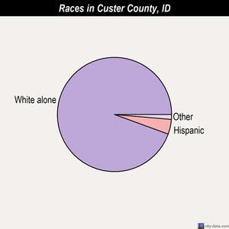
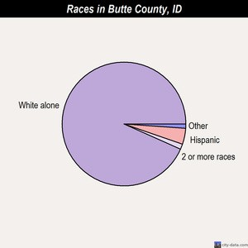
95.6% White, 3.6% Hispanic 95.8% White, 1.9% Hispanic

- Agricultural Statistics

Agriculture in Butte County:

Average size of farms: 616 acres
Average value of agricultural products sold per farm: $246,582
Average value of crops sold per acre for harvested cropland: $221.16
The value of livestock, poultry, and their products as a percentage of the total market value of agricultural products sold: 78.28%
Average total farm production expenses per farm: $195,383 Harvested cropland as a percentage of land in farms: 39.33% Irrigated harvested cropland as a percentage of land in farms: 99.70%
Average market value of all machinery and equipment per farm: $80,485 The percentage of farms operated by a family or individual: 87.31% Average age of principal farm operators: 54 years
Average number of cattle and calves per 100 acres of all land in farms: 12.92
Milk cows as a percentage of all cattle and calves: 3.48%
All wheat for grain: 2951 harvested acres

Agriculture in Custer County:
Average size of farms: 462 acres
Average value of agricultural products sold per farm: $44,668
Average value of crops sold per acre for harvested cropland: $106.18
The value of livestock, poultry, and their products as a percentage of the total market value of agricultural products sold: 76.39%
Average total farm production expenses per farm: $48,012
Harvested cropland as a percentage of land in farms: 21.52%
Irrigated harvested cropland as a percentage of land in farms: 98.06% Average market value of all machinery and equipment per farm: $52,701 The percentage of farms operated by a family or individual: 82.46% Average age of principal farm operators: 54 years
Average number of cattle and calves per 100 acres of all land in farms: 19.40
Milk cows as a percentage of all cattle and calves: 0.02%

The agriculture products of the district ranked according to sales value are: grain (wheat, barley and oats), beef cattle, hay, seed potatoes, dairy and sheep. The total market value is approximately $23 million. Grains are used locally for feed or sold through area grain dealers. Livestock markets are in Idaho Falls, Blackfoot and Shoshone. Seed potatoes are sold by direct sale to potato farmers throughout southern Idaho.

Agriculture in the district is limited by short growing seasons, cold winters, limited irrigation water supply and in many cases shallow soils.

Section 3: Assessment
(IDAPA.60.05.02.025.03)

- Soil Resources
- Soil Erosion per year

Total Average Soil Loss/Acre

  - Pastureland
(Tons/Acre)

5,953 acres x .5 ton = 2,977 ton
15,058 acres x 1.0 ton = 15,058 ton
14,008 acres x 3.0 ton = 42,024 ton 60,059 ton 1.5
  - Cropland
70,114 acres x 4.0 ton = 490,798 ton 490,798 ton 7.0

  - Rangeland

20,268 acres x .5 ton = 10,134 ton
46,194 acres x 1.0 ton = 36,194 ton
47,558 acres x 1.5 ton = 71,337 ton
21,632 acres x 2.0 ton = 43,264 ton 160,929 ton 1.25

4. Streambanks | 100,000 ton
5. Federal Land
1,930,096 acres x 1.5 ton = 2,895,144 ton | 2,895,144 ton | 1.5
Total Soil Loss in the District | 3,606,930 ton

- Soil Quality

No highly erodible lands exist in the District, although soil erosion is still a concern.

An estimated 500 acres of irrigation caused erosion needs conservation plans. Practices such as land leveling, irrigation ditches, structures for water control and sprinkler systems could be used to control erosion.

Wind erosion of soils is a localized concern on about 1500 acres.

- Water Resources (quantity)

- Surface water (covered in Section 5)

- Ground Water

Ground water levels and adequacy of subsurface supply varies considerably throughout the district depending upon geographic location of the well, the aquifer from which the well produces water, etc. Ground water is adequate for present and future domestic needs.
Many farmers supplement their surface water by pumping from wells. Some of this is done by pumping from wells located off the farm in areas where the water table is near the surface into the canals, which then deliver water to the farms.
Well depths to pure water vary by location. Water table levels in the Howe area vary from 40 to 100 feet below the surface. Between Howe and the Snake River Plain, the water level gets progressively deeper. Near Arco, ground water is found in at least three separate zones, the largest of which is 25 to 100 feet below the surface. During drought years domestic wells continue to go dry.
The quality of the subsurface water is generally good if the wells are constructed properly and protected from contamination. Prudent use of herbicides and pesticides and disposal of chemical containers need to be emphasized.
The water contains calcium and magnesium bicarbonate and is moderately hard to hard. It is satisfactory for irrigation use but is less desirable for domestic use.
The major uses of groundwater in the BSWCD are crops, recreation and domestic.
To achieve the desired groundwater quality, continued education in the use of chemicals and disposal plan for containers needs to be carried out. Proper maintenance of irrigation systems would also benefit the ground water.

- Flooding

Winter flooding has been a major problem around the town site of Howe. The flat grade of the river causes slower water flow. The water freezes and blocks the channel causing flooding. In 1984, the High Country RC&D combined with the effort of the National Guard and the Little Lost River Improvement District to construct sink trenches. The Little Lost River is diverted into these sink trenches when there is freezing danger. This has stopped the flooding problems in Howe.
Flooding on the Big Lost River is a frequent problem. Big floods occurred in 1965, 1967 and 1986. These floods took out several bridges and damaged highways and county roads. However, the more frequent damage is the increase erosion on streambank and the flooding of cropland.
Streambank erosion is common throughout the Big Lost River Valley. A 208 water quality planning project done in 1982 identified 31 critical erosion sites above the Mackay Reservoir, which needed major streambank erosion control measures. There are even more sites below the dam that are critical.
A flood control project on the Big Lost River could take the peak off the runoff, reduce erosion considerably and make streambank erosion control measures much less expensive. This project could also store irrigation water it would be very helpful on dry years.

- Air Quality

2005 air pollution in Butte County:
Ozone (1-hour): 0.054 ppm (standard limit: 0.12 ppm). Significantly below U.S. average.
Ozone (8-hour): 0.048 ppm (standard limit: 0.08 ppm). Significantly below U.S. average.

Read more: http://www.city-data.com/county/Butte_County-ID.html#ixzz1ntNZFK9l

- Fish and Wildlife

  - Threatened and endangered species

The threatened species that may be found in Butte and Custer counties as lynx, Lynx canadensis, and the bull trout, Salvelinus confluentus, Greater Sage-Grouse,
Centrocercus urophasiunus
(http://fishandgame.idaho.gov/cdc/t&e.cfm). However bull trout are not known to be located in the Big Lost River subbasin according to fish distribution data
(http://map.streamnet.org/website/bluesnetmapper/viewer.htm).

The strictly cold-water rivers, streams, reservoirs and alpine lakes provide habitat
for fish; rainbow, cutthroat, bull trout and eastern brook trout as well as whitefish. The District supports appropriate protection and restoration measures for bull trout. The water provides habitat for resident and migratory waterfowl.

The landforms provide habitat for big game and non-game animals and birds. Resident mammals include mule deer, elk, antelope, mountain sheep and goats, bear cougar, badger, coyote, bobcat, beaver and many smaller mammals. Resident non-waterfowl include pheasant, dove, Hungarian and chukar partridge, sharptail and sage grouse, bald and golden eagle and many species of song and field birds.

- District Operations

  - Financial - County support has remained stable. The State funding of two to one match has declined due to the overall economic downturn in the State of Idaho. Additionally some SWCDs are receiving increased appropriations from counties and cities which also impact the amount of funds available to disperse to SWCDs.

  - Administration - Butte SWCD supervisors have strong administrative capabilities because of rotation of officers each year.

  - Technical Assistance - Technical assistance has increased 30% during the past 3 years with the assignment of an NRCS Soil Conservationist to the office, a Soil and Water Conservation Commission employee and a Range and Wildlife Conservationist with The Sage-Grouse Initiative.

Section 4: Identify and Prioritize Objectives
(IDAPA 60-.05.02.025.04)

- Water Quality and Water Resources (quantity)
- Cropland, Pasture and Rangeland (irrigated and Non-irrigated)
- Sage Grouse
- Animal Waste Management and Riparian
- Information and Education
- District Operations

Section 5: Water Quality
(IDAPA 60-.05.02.025.05)

The major drainages in the Butte SWCD are the Little Lost and Big Lost Rivers. These large basin tributaries lie along the northwest flank of the Snake River Basin. The water from these rivers has been cut off from the Snake River by lava flows. No surface water from the Lost Rivers reaches the Snake River because the rivers sink in basins located east of Howe. It is thought that the water contributes heavily to spring flows in the Snake River canyon near Buhl and Hagerman. This sinking of the rivers is not confined to the final basin. At low to medium flows the water of the Big Lost River sinks and reappears several times in its journey down the valley. This is caused by large, deep areas of gravel that let the water sink. These are interrupted by rock ledges that block the underground flow and cause the water to rise.

The Little Lost River drainage includes approximately 900 square miles of drainage area. The Little Lost River is formed at the confluence of Sawmill and Summit Creeks. Two other important tributaries are Dry Creek and Wet Creek. Total winter yield of the Little Lost River varies from 100,000 to 2,000 acre-feet annually with an average of 41,000 acre-feet reaching Howe for irrigation purposes. Irrigation water delivery is managed by the Little Lost River Irrigation District. There are no storage facilities on the Little Lost River, which presents serious water storage problems during the dry years.

The Big Lost River drainage includes approximately 1,400 square miles. The Big Lost River is formed at the confluence of the East Fork and North Fork. The major tributary of the North Fork is Summit Creek. The

average water available for irrigation from the Big Lost River as measured near Mackay is 208,000 acre-feet annually. Total yield varies from 175,000 to 400,000 acre-feet. Irrigation water above the Mackay Reservoir comes from the Big Lost River and various creeks and springs. Antelope Creek, Pass Creek, Champagne Creek and other small streams provide irrigation water to small acreages of irrigated cropland and pasture.

The Big Lost River Irrigation District manages the delivery of water to all the farms below the Mackay Reservoir. This includes approximately 37,800 acres of cropland and pasture supplied by surface and another 300 acres of water supplied entirely by pumps. The Mackay Reservoir has a capacity of 44,000 acre-feet and is empty by fall many years. Irrigation water is short during dry years. This shortage is increased by water loss in the delivery system and poor efficiency of on-farm systems. The Big Lost River Irrigation District keeps good records on loss in each canal.

A reservoir management plan with the Big Lost River Irrigation District in cooperation with NRCS Snow Survey has been used to reduce flood peaks. Improvement of irrigation canals and delivery ditches is needed to stop water losses. Irrigation water management on the cropland is also needed.
Butte SWCD priorities on nor fully supported 303(d) water bodies.

Water quality in the streams is generally good late in the year. During high water, water quality is poor due to excessive sediment. Most of this is caused by streambank erosion.

Streambank erosion problems are caused by a variety of conditions such as high runoff from snow melt, fragile soils, stream straightening, and damage to riparian areas by grazing cattle. The Big Lost River and many of the tributary streams move across the valleys changing course frequently by cutting and depositing soil, gravel and rocks. Major changes and streambank erosion take place during high runoff years. Even though this erosion is natural it causes large economic losses by cutting into cropland, irrigation systems, homes, highways and bridges.

Stream channel straightening to prevent water loss in sink areas or to stop streambank cutting has caused some tremendous erosion problems on the Big Lost River and some tributaries. An area of Sawmill Creek, a tributary of the Little Lost River has some streambank erosion problems due to the stream straightening and a fire that destroyed riparian vegetation from re-establishing which resulted in streambank cutting. This area has been fenced off with RC&D funds to promote healing of the streambank.

Cattle grazing causes damage to riparian vegetation and causes some streambank erosion. In most cases cattle grazing is a secondary cause of erosion that increases erosion caused by natural stream channel movement or stream straightening.

A flood control project that could take the peak off the runoff would reduce erosion considerably and would make streambank erosion control measures much less expensive.

Control of stream channel erosion needs a combination of rock riprap, vegetative plantings and riparian area management.

Office of Species Conservation has a water quality project on a ranch in Little Lost. Several riparian tree planting projects are underway.

BUTTE SWCD (§303(d)) STREAMS

17040217 Little Lost

ID17040217SK001_05 Little Lost River -canal (T06N, R28E) to playas 18.62 MILES

Temperature, water
ID17040217SK002_05 Little Lost River -Big Spring Creek to canal (T06N, R28E) 5.77 MILES
Combined Biota/Habitat Bioassessments Temperature, water

ID17040217SK003_02 Big Spring Creek -source to mouth 8.1 MILES

Temperature, water
ID17040217SK003_03 Big Spring Creek -source to mouth 7.1 MILES

Temperature, water Cause Unknown
ID17040217SK003_04 Big Spring Creek -source to mouth 1.98 MILES

Temperature, water
ID17040217SK007_02 Little Lost River -Badger Creek to Big Spring Creek 79.14 MILES

Fishes Bioassessments Sedimentation/Siltation Temperature, water
ID17040217SK007_04 Little Lost River -Badger Creek to Big Spring Creek 14.14 MILES

Combined Biota/Habitat Bioassessments
ID17040217SK009_02 Little Lost River -Wet Creek to Badger Creek 54.26 MILES

Sedimentation/Siltation Temperature, water
ID17040217SK010_04 Little Lost River -confluence of Summit and Sawmill Creeks 8.56 MILES

Combined Biota/Habitat Bioassessments
ID17040217SK014_02 Sawmill Creek -confluence of Timber Creek and Main Fork to 33.78 MILES

Temperature, water
Combined Biota/Habitat
Bioassessments This watershed is moderately to heavily grazed during the summer months. 1-12-10
SR

ID17040217SK015_02 Squaw Creek -source to mouth 12.53 MILES

Temperature, water
ID17040217SK018_03 Timber Creek -source to mouth 1.48 MILES

Temperature, water
ID17040217SK019_02a Moffett Creek 1.35 MILES

Combined Biota/Habitat Bioassessments Temperature, water
ID17040217SK019_03 Summit Creek -source to mouth 9 MILES

Temperature, water
ID17040217SK020_03 Dry Creek -Dry Creek Canal to mouth 14.64 MILES

Temperature, water
ID17040217SK021_02 Dry Creek -source to Dry Creek Canal 46.67 MILES

Temperature, water
ID17040217SK021_03 Dry Creek -source to Dry Creek Canal 2.69 MILES

Temperature, water
ID17040217SK023_02 Squaw Creek -source to mouth 25.9 MILES

Combined Biota/Habitat Bioassessments
ID17040217SK025_02 Deer Creek -source to mouth 17.21 MILES

Temperature, water

17040218 Big Lost

ID17040218SK002_06 Big Lost River -Spring Creek to Big Lost River Sinks (playa 72.2 MILES

Sedimentation/Siltation Temperature, water
Cause Unknown Nutrients Suspected ImpairmenttLow DO due to suspected Organic Enrichment
ID17040218SK009_02 Pass Creek -source to mouth 50.16 MILES

Combined Biota/Habitat Bioassessments
ID17040218SK013_05 Big Lost River -Jones Creek to McKay Reservoir 4.03 MILES

Sedimentation/Siltation

Cause Unknown Nutrients Suspected Impairment
ID17040218SK015_05 Big Lost River -Thousand Springs Creek to Jones Creek 4.77 MILES

Sedimentation/Siltation

Cause Unknown Nutrients Suspected Impairment
ID17040218SK016_02 Thousand Springs Creek -source to mouth 20.15 MILES

ID17040218SK020_03 Willow Creek -source to mouth 4.05 MILES

Combined Biota/Habitat Bioassessments
ID17040218SK022_02 Sage Creek -source to mouth 35.64 MILES

Fecal Coliform
ID17040218SK024_02 Big Lost River -Burnt Creek to Thousand Springs Creek 98.61 MILES

Combined Biota/Habitat Bioassessments
ID17040218SK024_03 Big Lost River -Burnt Creek to Thousand Springs Creek 1.4 MILES

Combined Biota/Habitat Bioassessments
ID17040218SK024_05 Big Lost River -Burnt Creek to Thousand Springs Creek 21.44 MILES

Sedimentation/Siltation
ID17040218SK025_02 Big Lost River -Summit Creek to and including Burnt Creek 30.42 MILES

Combined Biota/Habitat Bioassessments
ID17040218SK026_02 Bridge Creek -source to mouth 21.49 MILES Cause Unknown Nutrients Suspected Impairment ID17040218SK026_03 Bridge Creek -source to mouth 3.94 MILES
6/28/2011 (NED) -On page xix of the Big Lost Subbasin Assessment and TMDL, it

Temperature, water
states that there was not sufficient temperature data to develop a TMDL for thermal loading.

ID17040218SK030_04 Wildhorse Creek -Fall Creek to mouth 4.95 MILES

Fecal Coliform

Section 6 – Identify and Prioritize Projects - projects found by the District to be appropriate for both impacted waters and stream segments of concern
(IDAPA 60-.05.02.025.06&07)
- Rangeland

Status: Rangeland in the Butte SWCD is generally large units of native vegetation or crested wheatgrass pastures. Approximately 75% of the range has problems with excessive brush. Overgrazing or grazing to close is a common problem that has left approximately 70% of the range in poor condition. Stockwater availability and distribution are a problem on approximately one-third of the private range. Most of the private range owners also graze on public land. Approximately 50% of these could benefit from coordinated resource planning or closer cooperation with the BLM and Forest Service.

Needs:
  - Brush management on 40,000 acres
  - Prescribed grazing on 85,000 acres
  - Spring developments, pipelines, reservoirs and wells on 40,000 acres
  - Ten coordinated range plans

- Pastureland

Status: Pastureland includes everything from well-managed irrigated pasture to occasionally watered fields, to native or introduced grasses in corners of farms and along streams. Sometimes a crop of hay is taken off and regrowth is grazed in the fall. Pasture problems include overgrazing, weeds, poor irrigation, no rotation system and poor forage species. We estimate that the pastures need improved management in one of these areas.
Needs:

  - Pasture management on 20,000 acres
  - Improved irrigation systems on 15,000 acres
  - Noxious weed control on 9,000 acres
  - Wind erosion conservation measures on 1,500 acres
  - Noxious weed control on 9,000

- Riparian and Streambank

Status: Streambank erosion is the most critical soil erosion problem in the district. The Big Lost River needs a flood control measure that will take the peak off the runoff. It needs streambank protection on an estimated 100 sites. Streambank protection is needed on an estimated 20 additional sites on the Little Lost and tributary streams to both the Little Lost and the Big Lost. Trail Creek on the Antelope drainage has a major problem of stream channel cutting that needs to be corrected.

- Weeds

Of Idaho’s 64 listed noxious weed species, there are 18 that have established infestations within the Butte SWCD. These species are listed below.

Black Henbane Canada thistle

Diffuse Knapweed Field Bindweed Houndstongue Japanese Knotweed Leafy Spurge
Musk Thistle Perennial Pepperweed Puncturvine
Rush Skeletonweed Russian Knapweed Saltcedar
Scotch Thistle Spotted Knapweed White Bryony Whitetop
Yellow Toadflax

Four of these species are of special concern to land managers within the SWCD due to widespread impact on agriculture. These species, the justification for special concern and approximate acreages in the Butte SWCD are cited below:

Leafy Spurge: Leafy spurge is an exotic perennial plant with an extensive root system. It can easily out compete most native vegetation and has taken hundreds of acres of farm ground and rangeland out of effective production within the SWCD. Approximately 5,200 acres with the SWCD are infested with leafy spurge at present. These infestations are primarily confined to the Big Lost River Valley. Biological control along with a consistent chemical treatment program have proven effective management tools in containing leafy spurge infestations.

Russian Knapweed: Russian knapweed, like leafy spurge, is an exotic perennial species that is difficult to control. An extensive root system and high herbicide tolerance make it a problem to croplands. Approximately 700 to 900 acres are infested within the BSWCD. Sizeable infestations of Russian knapweed in the Butte SWCD are listed in order of size from greatest to least.

-South side of Arco (500 acres)
-3400 North above Moore (100 acres)
-Badger Creek near Clyde (60 acres)
-3700 Northeast of Howe (30 acres)

Chemical control of Russian knapweed is the only feasible control option at this time and is difficult in cropland environment.

Spotted Knapweed: Spotted knapweed is an introduced invasive plant that possesses the capacity to spread rapidly and consume acreages displacing more favorable native vegetation. The spotted knapweed life cycle can be either biennial or short-lived perennial. Spotted knapweed particularly threaten riparian and rangelands. At present spotted knapweed infests approximately 500-1000 acres, primarily along highway 93 and the Big Lost River throughout the length of the Big Lost River valley.

Whitetop: Whitetop is a well-established perennial invader that has taken a strong foothold throughout the agricultural portions of the Big and Little Lost River Valleys, particularly in the Arco and Howe areas where

several hundred acres are infested. It is spread primarily through fragmentation of rhizomes through cultivation. Few herbicides effectively control whitetop especially in cropland and no bio-control agents are available in the BSWCD.

The most feasible means of control for these species are herbicide applications.

There are several species of special concern in the SWCD. Like the aforementioned established species rush skeletonweed, salt cedar and houndstongue pose a real threat to lands within the SWCD.

Rush Skeletonweed: Isolated infestations of rush skeletonweed have been identified throughout the BSWCD since 2003. These sites were scattered from upper Antelope Creek and Trail Creek Road to the Big Lost River sinks. Rush skeletonweed is an introduced difficult to control species that spreads via roots and wind disseminated seeds. All care should be taken to prevent infestations of rush skeletonweed from establishing within the BSWCD. A variety of herbicides provide effective control of rush skeletonweed.

Perennial Pepperweed: Perennial Pepperweed infestations have been mapped in south Custer County near the Mackay Reservoir. It is a stubborn plant that that grows in a variety of habitats. Perennial Pepperweed can propagate via either deep creeping rhizomes or by seed. Herbicides are the most effective control option for perennial pepperweed.

Houndstongue: Houndstongue is a non-native plant poisonous to livestock. It spreads through adhesive seeds that often become attached to animals. A large infestation of houndstongue is scattered to the south of Arco in marsh areas which areas at this date are dry. While spread rates and influence to native species are less dramatic with houndstongue than others of our special concern species, it is a priority due to its toxicity. Houndstongue is spreading in the Howe area at an alarming rate though infestations are currently small.

Several other plant species are categorized as noxious by the State of Idaho have been reported or documented at this time. These plants are either eradicated or are no longer detected. These species are:

Buffalobur Dyer’s Woad
Dalmatian Toadflax

- Cropland

Status: Cropland is all irrigated with 30% being flood irrigated and 70% being sprinkler irrigated. Poorly designed sprinkler systems are causing a poor watering pattern and a waste of electricity. Sprinkler systems in the Butte SWCD need to be carefully designed to provide the needed water at a minimum cost. Erosion problems are listed under the erosion section of soils in the Five-Year Plan. Other problems on cropland include fertilization and management of hay crops, weeds on abandoned cropland and Canada thistle and leafy spurge.

Needs:

  - Improved sprinkler irrigation systems on 30,000 acres
  - Land leveling and improved irrigation ditches on 8,000 acres
  - FSA conservation compliance plans on 5,000 acres
  - Wind erosion conservation measures on 1,000 acres
  - Noxious weed control on 9,000 acres

Section 7 – Implementation

FY2016 (7/1/2016 – 6/30/2017) Annual Plan of Work
Butte Soil and Water Conservation District
For Information Contact: Randy Purser, Chairman
Telephone Number: 208-554-3831
Email:Frances.Perkes@id.nacdnet.net
Counties Served: Butte and South Custer
Legislative District: # 35
Jeff Siddoway, Van Burtenshaw, Paul Romrell

Conservation District Priority 1: Water Quantity and Quality Objective: To improve the use of irrigation water and water quality of any impaired water bodies.

Goal: Maximize the management of irrigation water and energy consumption

Actions |  |  | Target Date | Individual(s) Responsible
Conservation of resources education - Age and lifestyle appropriate |  |  | July -  June | Jeff Isham/NRCS
Determine and implement if practical a recharge program in BSWCD on Burnett Ditch on the Big Lost and Blaine Ditch on the Little Lost  River. |  |  | July - June | Randy Purser/NRCS
Facilitate public meetings on alternatives for large scale irrigation water conservation (i.e. – pipeline, energy conservation) |  |  | July –  June | Jeff Isham/NRCS
Cloud Seeding  Schedule Pan Herdrich, High Country RC&D Coordinator to determine and or improve cloud seeding effort in Butte and Custer  counties |  |  | July - June | Jeff Isham/NRCS

Conservation District Priority 2: Cropland, Pasture, Rangeland Objective: Improved Hay land Management and Conservation
Goal(s): Promote and coordinate conservation programs to assist producers with
technical and financial assistance to improve soil health, control erosion, through the implementation of Best Management Practices.
Actions | Target Date | Individual(s) Responsible
Irrigation Energy and Water Management  - Encourage producers to apply for Equip or other cost share  Programs to increase irrigation efficiencies | July -  June | Todd  Perkes/Public Outreach Coordinator  NRCS
Work with Butte County CES to develop an awareness and program for pest management in production pasture, hay land and cropland | July - June | Todd Perkes/ NRCS
Nutrient Management  - Develop nutrient management plans for producers to help save money, improve productivity, and protect water resources.  - Follow up with CSP contract holders on implementation of nutrient management. | July - June | Mark Telford/ NRCS
Promote improved hay/forage seed varieties for improved hayland productivity. | July -  June | Mark Telford/  NRCS
Agency coordination and communication | July - June | Mark Telford/ NRCS
Wildlife  - Encourage shelter belt planning and application  - Follow up on CSP delayed haying enhancement to facilitate enhanced wildlife habitat  - Work with NRCS, Pheasants Forever on Sage Grouse Initiative | July - June | Mark Telford/ NRCS

Objective: Improved Irrigated Pasture Management

Goal(s): Promote and coordinate conservation programs to assist producers with technical and financial assistance to improve soil health, control erosion, through the implementation of Best Management Practices.

Actions | Target Date | Individual(s) Responsible
Promote improved forage seed varieties for improved pasture and rangeland seedings. | July - June | Walt Johnson/ NRCS
Develop stock watering systems as components of grazing  management systems for improved utilization of resources | July -  June | Walt Johnson/  NRCS
Assist producers with planning and implementation of rotational grazing plans | July - June | Walt Johnson/ NRCS

Objective: Help cooperators enhance rangeland condition and trends.

Goal: Provide information to livestock producers to help them decrease overgrazing/over-resting of soils and plants and graze a high proportion of range plants at a moderate level of use.
Actions | Target Date | Individual(s) Responsible
Promote and encourage stockmanship and animal behavior to  improve rangeland conditions | July -  June | Walt Johnson
Pest Management  - Consider a cooperative workshop with CES and Lost Rivers CWMA on weeds and rodent control and IPM | July - June | Randy Purser
Predator Control  - Cooperate and work with agencies and entities on predator issues | July -  June | Randy Purser
Encourage the development of stock water systems as a  component of a grazing management system. | July -  June | Walt Johnson
Encourage and coordinate agency coordination | July - June | Supervisors

Conservation District Priority 3: Animal Waste Management and Riparian Goal(s): Help keep producers in compliance with Clean Water Act.
Objective: Obtain funding sources for implementation of AFO/CAFO projects and riparian improvement through EQIP, cCRP and 319 program.
Actions | Target Date | Individual(s) Responsible
Follow up on 319 project application | October | District  Employee
Inform producers about EQIP and cCRP information | July - June | BSWCD/NRCS

Conservation District Priority Number 4: Information and Education Objective: Develop and Present Educational Programs
Goal(s): Youth Resource Education Programs
Actions | Target Date | Individual(s) Responsible
Envirothon (9-12th grades)  Butte SWCD will sponsor three teams and provide resource education training | Aug-May | Outreach  Coordinator  Admin Assist
6th Grade Poster Contest  Students from Mackay and Arco – approximately 60 | Feb/March | Outreach Coordinator
Stewardship Week/Ag Day (K-5th grades) Approximately 150 students | Feb/April | Outreach Coordinator
Natural Resources Workshop (7th grade)  Coordinate scholarships for 10-12 students – Butte SWCD | May/June | Outreach Coordinator
6th Grade Natural Resources Workshop  Students from Mackay and Arco – approximately 60 | Aug/Sept | Outreach Coordinator

Conservation District Priority 4: Information and Education – continued

Objective: To increase cooperator knowledge of conservation of natural resources and Soil Health.
Goal(s): Adult resource education to help improve economic and resource health of farms and ranches.

Actions | Target Date | Individual(s) Responsible
Conduct or assist with five informational activities on:  a) irrigation, b) pasture management, c) tree maintenance , d) CSP rules,  e) Pest Management, f) weeds, g) cover crops | July -  June | NRCS/Board
Promote coordination and cooperation among the Idaho  Conservation Partners  - Review Memorandum of Agreements  - Review and discuss the roles and responsibilities of the Idaho Conservation  Partnership | Jan | Chairman
Participate in Community Fairs  - Participate in County Fairs with a booth  - Take part in city or community fairs | July - June | Outreach Coordinator/Board
Continue to market Stockmanship Manual  - Fill all orders for Stockmanship Manual in a timely manner.  - Promote Stockmanship Manual as a component of grazing management | July - June | Admin Assist Board
Support CES Pasture School  - The Butte SWCD will assist CES with funds, promotion, outreach, etc. | Spring | Admin Assist Board

Conservation District Priority Area Number 4: District Operations Objective:

Goal: Increase effectiveness of supervisors in carrying out the functions of the district

Actions | Target Date | Person(s) Responsible
Update or develop a Policy and Procedure Manual for Butte SWCD  Set Policy of supervisors duties (nominees must be informed of duties before elections) | July | Chairman
Appoint supervisors to be in charge of:  - District Operations  - Financial  - Resource Planning and Operation  - Public Outreach  - Elections | July | Chairman
Encourage meeting attendance  - Monthly board meetings (quorum of three supervisors  - Division VI meetings (2 supervisors)  - IASCD Conference (2 supervisors)  - Attend and/or assist district sponsored events  - Attend other meetings as assigned (NACD, RC&D, local committees) | July - June | Chairman, Admin Assist
Continue SCD/FSA involvement in Conservation Programs | July - June | Jeff Isham
Keep informed and be environmentally sensitive | July - June | Supervisors

Conservation District Priority Number 4: District Operations, continued

Actions | Target Date | Individual(s) Responsible
Keep the District financially sound and fiscally responsible  - Supervise the financial record keeping  - Two supervisors will sign checks (employees will not sign checks)  - Treasurer’s report will be reviewed at board meetings  - A monthly budget will be prepared annually  - Letter of Intent will be obtained from Butte and Custer counties  - Submit Certificate of Receipt of county funds to SCC  - Financial records will be reviewed annually  - Reports will be submitted in a timely manner  - Pay NACD, IASCD, Div VI, RC&D and IDEA dues | July - June | Treasurer
Comply with Idaho’s Open Meeting Law  - Meetings will be open to public  - Notice of meetings will be given five calendar days prior to meeting  - Post meeting agenda 48 hours prior to meeting  - No special meetings will be held without 24 hours notice unless emergency exists  - SWCD will comply with Idaho Public Records Law to examine SWCD records  Fee to copy will be $.10 per page. Requests will be in writing. | July - June | Chairman  District Employee
Will notify Idaho NRCS of District priories  - Review Annual Plan of Work and set priorities | July | Chairman
Civil Rights  - Provide assistance without regard to race, color, national origin, age, sex, religion, marital status, or handicap  - Review Americans with Disabilities Act  Ensure SWCD programs are available to people with disabilities in the following areas: employment, facility accessibility and parking, communications and meetings. | July - June | Board
District Employees  - Annual evaluation of job description  - Review and up-date working agreement with employees annually  - Evaluate Employment needs annually  - Encourage attendance of meetings (IASCD, Div VI, IDEA)  - Determine an employee(s) development plan, i.e. courses, workshops or seminars | July -  June | Chairman

APPENDIX A - Soils

General Soil Map Legend – Butte County

SOILS ON STREAM TERRACES, FLOODPLAINS, AND FAN TERRACES

General Soil Map Unit 1: Techick-Soelberg-Zer
Very deep, level to gently sloping, well-drained soils formed in mixed alluvium
Percentage of survey area: 6
Landform: Techick – fan terraces and stream terraces Soelberg – fan terraces and stream terraces Zer – fan terraces
Elevation: 4,700 to 5,800 feet
Frost-free period: 70 to 90 days Average annual precipitation: 8 to 12 inches
Minor components: Bockston, Blackfoot, Borco, Mooretown, Starlite and Whiteknob Major use: irrigated cropland, irrigated pasture and rangeland

General Soil Map Unit 2: Mooretown-Dickeypeak-Thosand
Very deep, level to gently sloping, somewhat poorly drained soils formed in mixed alluvium.
Percentage of survey area: 1
Landform: Mooretown – streams terraces and floodplains Dickeypeak – stream terraces and floodplains Thosand – stream terraces and floodplains
Elevation: 5,000 to 6,100 feet
Frost-free period: 45 to 80 days
Average annual precipitation: 9 to 11 inches
Minor components: Arco, Crooked Creek, Bigrant, Borah and Sancrane soils Major use: irrigated pasture, irrigated cropland and nonirrigated pasture.

SOILS ON LAVA PLAINS

General Soil Map Unit 3: Nargon-Coffee-Atom
Moderately deep to very deep, level to moderately steep, well-drained soils formed in mixed alluvium from loess and
basalt
Percentage of survey area: 24 Landform: Nargon - lava plains
Coffee - lava plains Atom - lava plains
Elevation: 4,500 to 5,800 feet
Frost-free period: 70 to 110 days
Average annual precipitation: 9 to 11 inches
Minor components: Deuce, Menan, Pancheri, Polatis and Spilttop soils Major use: rangeland

General Soil Map Unit 4: McCarey-Beartrap-Techicknot
Moderately deep to very deep, level to moderately steep, well-drained soils formed in mixed alluvium from loess and basalt
Percentage of survey area: 18
Landform: McCarey - lava plains
Beartrap - mounds on lava plains Techicknot – basins of lava plains
Elevation: 4,500 to 5,800
Frost-free period: 60 to 100 days
Average annual precipitation: 9 to 15 inches
Minor components: Atom, Lava flows, Molyneux, Nargon, Splittop, Tenno and Vickton soils Major use: rangeland

General Soil Map Unit 5: Portino-Thornock
Moderately deep to shallow, gently to strongly sloping, well drained soils formed in loess, mixed Alluvium and residuum
from basalt
Percentage of survey area: 2 Landform: Portino - lava plains
Thornock - lava plains Elevation: 4,400 to 4,700
Frost-free period: 100 to 110 days
Average annual precipitation: 9 to 10 inches
Minor components: Kimama, McCain, McClendon, Minidoka and Truesdale soils Major use: rangeland

General Soil Map Unit 6: Malm-Matheson-Stan
Moderately deep to very deep, gently to strongly sloping, well-drained soils formed in eolian over residuum from basalt and mixed alluvium
Percentage of survey area: 2 Landform: Malm - lava plains
Matheson - lava plains
Stan - alluvial fans Elevation: 4,800 to 5,500
Frost-free period: 70 to 110 days
Average annual precipitation: 9 to 13 inches
Minor components: Bonfarm, Breitenbach and Grassy Butte soils Major use: rangeland

General Soil Map Unit 7: Huddle-Moonville-Hal
Very shallow to very deep, gently to strongly sloping, well-drained soils formed in eolian materials from volcanic ash and cinders over basalt
Percentage of survey area: 1 Landform: Huddle - lava plains
Moonville - lava plains
Hal - lava plains Elevation: 4,800 to 8,500 feet
Frost-free period: 50 to 90 days
Average annual precipitation: 12 to18 inches Minor components: Lava flows
Major use: rangeland

General Soil Map Unit 8: Lava flows-Pingree-Cinderhurst
Lava flows and very shallow, level to strongly sloping, well drained soils formed in loess and volcanic ash over residuum from basalt
Percentage of survey area: 9
Landform: Lava flows - lava plains
Pingree - lava plains Cinderhurst - lava plains
Elevation: 4,500 to 6,000
Frost-free period: 60 to 110 days
Average annual precipitation: 9 to14 inches Minor components: Deuce and Nargon soils Major use: rangeland
SOILS ON FOOTHILLS AND MOUNTAINS

General Soil Map Unit 9: Howcan-Hutchley-Hagenbarth
Shallow to very deep, strongly sloping to very steep, well-drained soils formed in slope alluvium and residuum from
volcanic rock.
Percentage of survey area: 5
Landform: Howcan - foothills and mountain sides Hutchley - ridges of foothills and mountains Hagenbarth - foothills and mountains
Elevation: 6,000 to 9,000 feet
Frost-free period: 45 to 80 days
Average annual precipitation: 12 to 18 inches
Minor components: Cronks, Dacron, Donkeyhill, Hondoho, Jonda, Frymire, Grouseville, Riverlost and Zeebar soils. Major use: rangeland, wildlife habitat
General Soil Map Unit 10: Ike-Jimbee-Bealand
Shallow to very deep, strongly sloping to very steep, well-drained soils formed in colluvium, residuum and slope alluvium
from limestone.
Percentage of survey area: 10
Landform: Ike - south facing ridges and convex area of foothills and mountains Jimbee - north facing ridges and convex areas of foothills and mountains
Bealand - foothills and mountainsides
Elevation: 5,000 to 9,000 feet Frost-free period - 40 to 80 days
Average annual precipitation: 8 to 18 inches
Minor components: Inel, Nitchley, Simeroi and Zeale soils Major use: rangeland, wildlife habitat

General Soil Map Unit 11: Mogg-Shagel-Zeebar
Shallow to very deep, moderately to very steep, well drained soils formed in colluvium, residuum, and alluvium from rhyolite, siltstone and quartzitic rock.
Percentage of survey area: 2
Landform: Mogg - convex ridges and lower south facing foothills and mountains Shagel - convex ridges and lower north facing foothills and mountains Zeebar - foothills and mountains
Elevation: 5,000 to 9,000 feet
Frost-free period: 40 to 90 days
Average annual precipitation: 10 to 18 inches
Minor components: Ketchum, Klug, Lag and Nurkey soils Major use: Rangeland and wildlife habitat

General Soil Map Unit 12: Lavacreek-Dollarhide-Vitale
Shallow to deep, moderately to very steep, well drained soils formed in volcanic ash, and colluvium and residuum from quartzitic sandstone and siltstone.
Percentage of survey area: less than 1
Landform: Lavacreek – north and east facing slopes on mountains
Dollarhid – ridges and north and east facing slopes on foothills and mountains Vitale – south and west facing slopes on mountains
Elevations: 5,200 to 9,300 feet
Frost-free period: 50 to 90 days
Average annual precipitation: 12 to 22 inches
Minor components: Grassycone, Hall, and Moonville soils Major use: Rangeland and wildlife habitat

SOILS ON FAN TERRACES, OUTWASH FANS AND FOOTHILLS

General Soil Map Unit 13: Simeroi-Sparmo-Fallert
Very deep, nearly level to moderately steep, well drained soils formed in alluvium from dominantly limestone and mixed sources
Percentage of survey area: 12
Landform: Simeroi – fan terraces, outwash fans, and foothills Sparmo – fan terraces and outwash fans
Fallert – fan terraces Elevation: 4,800 to 8,000 feet
Frost-free period: 60 to 90 days
Average annual precipitation: 8 to 12 inches
Minor components: Bluedome, Fandow, Goosebury, Leatherman, Paint, Sanfelipe, Slide and Whitecloud soils Major use: Rangeland

General Soil Map Unit 14: Zer-Snowslide-Soen
Very deep, nearly level to moderately steep, well-drained soils formed in alluvium from mixed sources.
Percentage of survey area: 7
Landform: Zer – fan terraces and foothills
Snowslide – fan terraces and toeslopes of foothills Soen – fan terraces and foothills
Elevation: 4,000 to 7,500 feet
Frost-free period: 60 to 90 days
Average annual precipitation: 8 to 12 inches
Minor components: Breitenbach, Buist, Bunting, Darlington, Dredge, Fulwider, and Lesbut soils Major use: rangeland

EXECUTIVE SUMMARY:
IDAPA 60.05.04

A: History

A hearing was held April 15, 1953 in Arco to discuss the formation of a soil conservation district. Twenty seven area farmers were present plus C.O. Youngstrom, Secretary of the State Soil Conservation Commission and R. N. Irving, of the Soil Conservation Service from Boise. Other Soil Conservation Service personnel from around the area included Tom McGowan, Idaho Falls, Don S. Douglas, Aberdeen, Glen Nielsen, Custer County, and Peter W. Taylor, Idaho Falls. Also attending was Milton Sill with the Forest Service, Lowell Moore, Supervisor West Side SCD District, Grover Jensen, State Legislator from Bonneville County and Aaron York, Butte County Agent.

Aaron York reported, “A request was made that we hold educational meetings to inform farmers what to expect of a soil conservation district. Three meetings were scheduled, one at Arco in the court room, one at Howe at the Bernice schoolhouse and one at the Moore schoolhouse.

Water conservation and water use is a definite problem in this area. Land leveling, soil fertility, crop rotation, introduction of new improved varieties of crops, use of windbreaks and tree planting programs were being stressed. Problems of range management and range reseeding are important. There is a definite problem in reestablishing trees that died when the Utah Construction Company took the water several years ago.”

A meeting was held May 23, 1953 at which time the landowners of the county voted to organize the Butte Soil Conservation District. In July 1953 the Secretary of State issued a certificate of organization to the Governor, through the State Soil Conservation Commission, and thereby, appointed two local farmers, Herman Fielding and Carl Rindfleisch, to serve as District Supervisors. They in turn conducted an election whereby three additional farmers were elected to serve on the board. They were Wendell Hansen, Clyde Lee and Clarence Hope.

The Certificate of Organization was signed July 23, 1953. When the district was first formed it included all the county of Butte except the incorporated villages and land owned by the Atomic Energy Commission. On June 27, 1967 the portion of Custer County south of the Willow Creek Summit in the Custer Soil and Water Conservation District was added to the Butte Soil and Water Conservation District. In 1986, the incorporated villages of Butte City (including Howe), Moore, Arco and Mackay were annexed into the district.

The board of supervisors recognized that the major conservation problem in the district was water conservation and the District should do everything possible to assist the farms and ranchers with this problem along with furnishing them technical assistance in reorganizing their irrigation systems and improving their methods of irrigation, that their land must be in the best possible condition in order to utilize their water and to have proper irrigation with land preparation such as land leveling and land plaining. The District purchased a cat and Hannock Scrapper. They rented out the cat for $10.00 per hour for land leveling and ditch building. Additional equipment purchased was another cat and dozer, a 1951 Ford 1½ ton truck and a service trailer and equipment.

The District was requested by the Directors of the Big and Little Lost River Irrigation Districts to conduct a water resources investigation of these watersheds.

Snow survey courses were established in the Little Lost River Watershed and the District sponsored forecast meetings at which the Soil Conservation Service Snow Survey Leader discussed the water outlook for the coming year.

Each year new cooperators were added and the District assisted the County ASC committee in serving ACP referrals. Irrigation projects were completed and an Information and Education program was started for the public and in the schools.

Butte SWCD was one of the sponsors of the Little Lost River Flood Control Project. The project consisted of excavating infiltration trenches, sinking the Little Lost River during winter months, and thereby preventing the winter flooding of the Howe area. Damages averaged $75,000. The project cost approximately $50,000 and has an anticipated life span of 50 years with proper maintenance.

Big Lost River Watershed was one of the first watershed in the United States to be included in the Conservation Security Program (CSP). Eighty farms were signed up for ten year contracts with annual payments of 2 million dollars...

In 2005 the Little Lost River Watershed was the only watershed in Idaho to be included in CSP. This was due mainly because a group of landowners met with the State Technical Committee in 2006 and requested that their watershed be included. All of the landowners in the watershed applied and 100% were funded. This will be an annual payment of 1 million dollars on five year contracts.

DISTRICT SUPERVISORS

Carl Rindfleish 1953 - 1955
Herman Fielding 1953 – 1955
Clarence Hope 1953 – 1959
Clyde Lee 1953 – 1959
Wendall Hansen 1953 – 1961
DeVon Jensen 1953 – 1975
Charles (Bud) Jones 1956 – 1962
Dean Waddoups 1957 – 1958
Harold Bell 1959 – 1983
Emlen Mays 1959 – 1978
William Martineau 1961 – Alternate
Don Aikele 1961 – 1963
L. R. Hawley 1961 – Alternate
Jess Amy 1961 – 1970
Reuben Jensen 1963 – 1975
Arnold Munson 1967 – Alternate
Gordon Harris 1967 – Alternate Jay
Pearson 1970 – 1972
Wiley Smith 1970 – 1980
Juel Aikele 1973 – 1978
Jack Jensen 1975 – 2003
Albert Fullmer, Jr. 1978 – 1986
Leo Amy 1978 – 1990
Tom Coates 1981 - 1986
Steven Aikele 1984 - 1986
Ron Chisham 1986 - 1990
Reed Asay 1986 - 1995
Randy Purser 1986 - ***
Jeff Isham 1989 - ***
Walt Johnson 1990 - ***
Sherrie Crawford 1995 - 2008
Laura Waddoups 2003 - 2013
Todd Perkes 2008 - ***
Mark Telford 2013 - ***

*** Current Supervisors and/or Employees

SCS/NRCS EMPLOYEES

Pete Taylor (Organized SCD) | 1953
Benny Martin, WUC | 1954 | - 1963
LeMon Baird, Cons. Aid | 1955
Billy McMurtrey, Tec. Engr. | 1961 | - 1979
Frank Dickson, DC | 1963 | - 1965
John Taggert, DC | 1965 | - 1966
James Stalnaker, DC | 1966 | - 1975
Arthur F. Hawk, DC | 1975 | - 1976
Ralph Swift, DC | 1976 | - 1979
Tony Bennett, DC | 1979 | - 1983
Mike Campbell, Engr. Tech. | 1979 | - 1980
Bill Jolley, Cons. Tech. | 1980 | - 1984
Mitch Flanagan, DC | 1983 | - 1987
Chris Merrill, Civil Eng. Tech. | 1985 | - ***
Scott Engle, Acting DC | 1987 | - 1988
Dan Holden, DC | 1988 | - 1994
Rick Hager, Acting DC | 1994 | - 1995
Steve Cote, DC |  | - 2014
Bruce Blackmer, Range Cons. | 2001 |  | - 201
Ryan Clayton, Soil Cons. | 2010 - |  | - 2013
Ryan Miller, Soil Cons. | 2013 - - |  | 2016

0

Jesse Fullmer, DC 2014 –
Lara Fondow, Soil Cons. 2016 -
DISTRICT EMPLOYEES
Beth Pearson | - |  | 1980
Cynthia Smith | 1980 - |  | 1981
Evelyn Clark | 1981 | - 1982
Karen Hinds | 1982 | - 1983
Leona Olsen | 1983 | - 1984
Frances Perkes | 1984 | - ***
Teena Lord | 2000 | - 2002

Teena Lord 2012 - 2014
Mindy Hawley 2015 - 2015

B: District Administration and Operation

Five supervisors manage the BSWCD program. They are elected to serve staggered four-year terms. Elections are conducted by the board of supervisors and/or are contracted by the Counties on the first Tuesday succeeding the first Monday of November in each even-numbered year following Idaho Soil Conservation Commission regulations. The past several elections have been successfully contracted with both Butte and Custer counties. Candidates receiving the highest number of votes are elected to office.

The BSWCD board meets monthly on the third Thursday of each month. The basic source of funds for the district are appropriations from Custer and Butte counties and the State of Idaho matching funds which are provided on a two for one match of the county funds received. The funds are allocated to the district following a public hearing which is held by the Idaho Soil Conservation Commission on or before June 15th of each year

and twenty (20) days written notice of such hearing shall be given to each Idaho Soil Conservation District and to all other persons requesting notice of such hearing. At the hearing the Idaho Soil Conservation Commission shall consider the needs of the district and shall base its request for state funds upon the budget, budget request, district programs and work plan, and work load analysis of the Butte SWCD. Since 1990, the Idaho Legislature provides $5000 base funding.

The district is concerned with total development, use and conservation of our soil, water and wildlife resources. Responsibilities include the conservation of water through Public Law 566, the small Watershed Act, assistance in the Rural Development Program, the development of our recreational and wildlife resources, land use and crop adjustments, cooperation with state and federal agencies on proper land management of public land, technical assistance for pollution abatement and land use planning.

BSWCD is a vehicle to provide information and technical guidance and to satisfy the need for local leadership in the conservation of the natural resources. The district can arrange for assistance to and from federal and state agencies, organizations and individuals.

The district actively seeks to maintain a good funding base through good relations with the Butte and Custer County Commissioners, State legislators and other local leaders. All district funds, regardless of source, are public funds are accountable to the taxpaying citizens of Idaho.

C: District Policies

- Services, programs and customers

  - To work with the counties to:
    - preserve prime agricultural lands for agricultural use
    - encourage the restriction of building on floodplains and high water table areas
    - to encourage orderly development of the natural resources through a comprehensive plan

  - To work with the public land administering agencies in the management of the soil, water and related resources of the public lands.

  - To work with the federal, state and local agencies in the management of the soil, water and related resources of the private lands.

  - To emphasize environmental quality in the conservation decisions made by the board.

  - To encourage all land use decisions to be guided by the multiple use principle.

  - To support sound water resource use decisions.

  - Butte SWCD willingly accepts the responsibility inherent to district to address agricultural nonpoint source pollution as set forth in the 1987 Water Quality Act – Section 319; the Safe Drinking Water Act 1986; and the Clean Water Act of 1972 – Antidegredation Program. The Butte SWCD accepts the responsibility in order to preserve a locally administered voluntary approach for control and abatement of agricultural nonpoint source pollution, and to protect and enhance the quality and value of water resources of the State of Idaho. Local streams are listed on the 303d list.

- In order to increase the effectiveness of the supervisors in carrying out the functions of the District the board has adopted the following guidelines:

- Follow general policies of conduct as set by IASCD and SWC.

- Follow local policies specifically adopted by Butte SWCD.

  - Appoint supervisors to oversee
    - District Operations
    - Financial
    - Resource Planning and Operation
    - Information and Education
    - Elections (even years – conducted with counties)

  - Attend meeting regularly
    - Monthly board meetings (quorum of three)
    - Division VI meetings (two supervisors)
    - IASCD Conference (two supervisors)
    - Attend and/or assist with District programs
    - Other meetings as assigned by the board

  - Rotation of district board responsibilities
    - Responsibility of chairman, vice-chairman and secretary-treasurer is rotated annually.
- The supervisors may be asked to resign or be recommended for removal from office if it is deemed they are not actively involved in carrying out their duties, powers, and responsibilities.

- Financial

  - Supervise financial record keeping
  - Two supervisors will sign checks (employees will not be on signature card)
  - Treasurer’s report will be reviewed at board meetings
  - A monthly budget will be prepared
  - Letter of intent will be obtained from Butte and Custer counties
  - Submit Certificate of Receipt of county funds to SCC
  - Books will be reviewed or audited bi-annually or annually per SCC requirements.
  - Reports will be submitted in a timely
  - Pay NACD, IASCD, Div VI, RC&D and IDEA dues

- Comply with Open Meeting Law

  - Meetings will be open to public
  - Notice of meetings will be given five calendar days prior to meeting
  - Post meeting agenda 48 hours prior to meeting
  - No special meeting will be held without 24 hour notice unless an emergency
  - SWCD will comply with public rights to examine SWCD records
  - Fee to copy a single page will be $.10, requests must be in writing

- Civil Rights

  - Provide assistance without regard to race, color, national origin, age, sex, religion, marital status or handicap
  - Review Americans with Disabilities Act
  - Insure SWCD programs are available to people with disabilities in employment, facility and parking accessibility, communications and meetings.

- Personnel policy and working agreements

D. Cooperating Conservation Partners, Agencies and Organizations

The Butte SWCD cooperates with the Natural Resources Conservation Service (NRCS) by providing an annual work plan and district report which identifies priorities of the Butte SWCD and progress toward these goals. The District will provide a good education and information program to help NRCS with conservation programs. The NRCS has agreed to spend at least part of their time on Butte SWCD priorities.

The Butte SWCD will work with Farm Services Agency (FSA) to ensure that conservation programs that are currently in effect are made available to local landowners and operators.

High Country RC&D cooperates with the Butte SWCD in identifying projects that need to be done and will seek local sponsors for projects. The District will also support RC&D efforts in our district and other districts.

Butte SWCD has and will continue to work with the Forest Service, Bureau of Land Management, Idaho Department of Lands, Cooperative Extension Service and the Idaho Department of Fish and Game on Coordinated Resource Management Plans.

The district has a Cooperative Agreement for Partners of Wildlife projects with U.S. Fish and Wildlife Service for the purpose of involving private landowners and other organizations in the restoration of fish and wildlife habitat on private lands.

Butte SWCD has an active Sage Grouse Iniative project in progress that is in cooperation with NRCS and Pheasants Forever.

The Cooperative Extension System and the Butte SWCD have and will continue to cooperate on forage crop projects and weed control.

We cooperate with the Butte and Custer County Commissioners on weed control, flood control and erosion damages to county roads and bridges.

The Butte SWCD works with public schools each year on land judging, 6th Grade Natural Resources tour and poster contest. We have been actively involved in the state and national Envirothon program since its introduction to Idaho and have sponsored teams from both high schools within the district.

Our district will work with other organizations as opportunities arise to achieve conservation through group efforts.
******************

